Joe Merrill 25JAN21
CMSC350 Project 1

UML Class Diagram

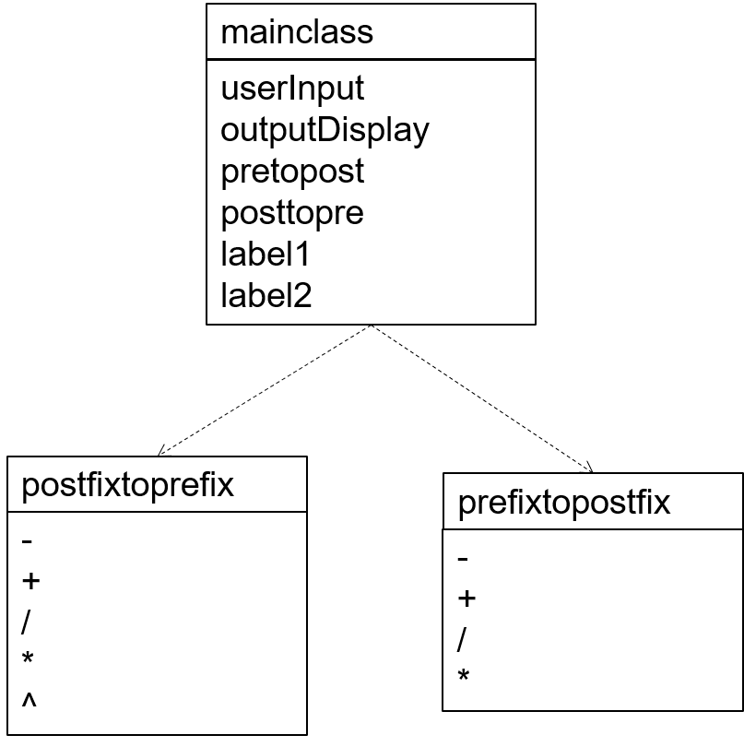

# | Input | Expected Output | Actual Output | Pass?
1 | ++A*BCD Pre to Post | ABC*+D+ | ABC*+D+ | Yes
2 | +*AB*CD Pre to Post | AB*CD*+ | AB*CD*+ | Yes
3 | ABC*+D+ Post to Pre | ++A*BCD | ++A*BCD | Yes

This was quite difficult for me. It has been a few months since I programmed in Java. I had to re-learn some basics, but they came back quickly. It was also interesting to combine the programming with a bit of the math I have learned between then and now. I had to research the stack.pop commands for a while to understand them and get them to work.

